1. **Create a git repository for the project on Github**  
   <https://github.com/helldongdae/HGU_SE_PROF_SHIN_HONG>
2. **Write a Java file that receives command line inputs**<https://github.com/helldongdae/HGU_SE_PROF_SHIN_HONG>
3. 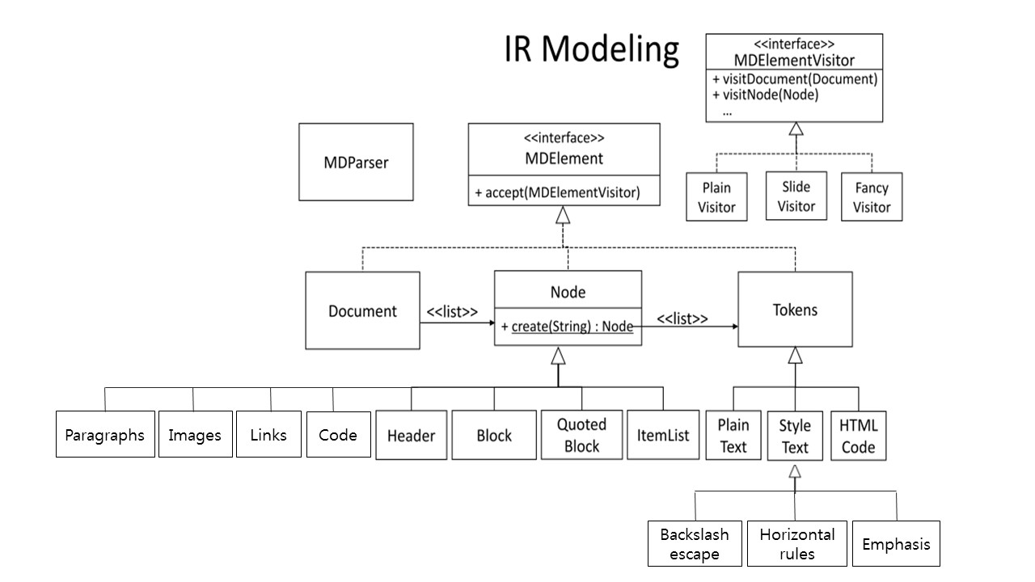**Design classes for Markdown IR based on the given skeleton.**

**\***

**Paragraphs** – This class deals the <br /> tag. The method transform will take place if the line ends with two or more spaces. It transforms its code and inserts the <br /> tag.

**Images** – This class deals with the <img> tags. The method transform will take place when it confronts the characters starting with an “!” followed by a set of square brackets, containing the alt attribute text for the image, followed by a set of a parentheses, containing the URL or path to the image, and an optional title attribute enclosed in double or single quotes. It will return with the image file instead of the codes.

**Links** – This class deals with the <a href> tag. The method transform will take place if “[“ + link_text+”](“ + url + “)” occurs in sequence. It will transform the code and return the string form of “<a href>= +url + link text + </a>”. Method automatic will take place if it encounters an URL or email address that is surrounded with < and >. This will transform the code and return <a href=”surrounded text”> surrounded text </a>.

**Code** – This class deals with the <code> tag. This is different from the <pre><code> tag above.

The method transform will take place when some strings are wrapped with ( ‘ ) (apostrophe) it will generate the <code></code> in return. Ex - ‘printf()’ 🡺<code> printf() </code>

**Header** – This class deals with the <h#> tag. It contains the transform method just like the other classes. The method transform will take place when it encounters number of equal signs and dashes. Or when it encounters 1-6 hash characters. For the equal signs it will transform it in to first level header and it will transform it in to the second level header for the dashes. And depending on the number of 1-6 hash characters it will generate <h1>-<h6> tags in return.

**Block** – This class deals the <pre><code> tag. The method transform will take place in a line of the block that is indented by at least 4 spaces or tab. And it will stop when it reaches a line that is not indented.

**Quoted Block** –This class deals with html tag <pre> or <p>. Quoted block contains other Markdown elements, such as Lists, Headers. So the quoted block class can have other element objects. Also Quoted contents are presented as indented by using margin variable. For example, html code <pre style="margin-left: margin px;"> allows the user to change the margin px freely. Slightly similar, the quoted blocks will also contain these indents but with the fixed px of 40. Setting the margins can be achieved by using getMargin( ) and setMargin( ).

**Item List** – This class deals with html tags <ul> and <ol>. Item list is divided into two groups, ordered list and unordered list. Ordered list is mapped with <ol>, while the unordered list is mapped with <ul>. Item list is a structure that contains several data. *, -, + is syntax for unordered list. 1. , 2. (any integer number + . ) is syntax for ordered list. There will also be a method which will allow for the ordered/unordered list to call in the margin variable used in quoted block.

**Plain Text** –This class will handle the ‘pure’ text parts of the list that came from the node. Its method will not transform any part of the text provided and will just pass it in return as the string type as it has received.

**Backslash_Escape**. – This class deals with using special cases without making it have a special meaning/syntax. The method transform will take place when it encounters the “\” and will return the original form of characters without any of its original syntax effect.

**Horizontal_Rules** – This class deals with the <hr> tags. The method transform will take place when it encounters three or more hyphens or asterisks. It will generate the <hr> tag.

**Emphasis** – This class deals with the <em> and <strong> tags. The method transform will take place when the text is wrapped between single * or single_. It will apply <em> tag. When the text is wrapped between two * or two_ , it will apply the <strong> tag.

**HTML Code** –This class deals with the parts of the list from the node that consists html codes. This is needed since markdown itself allows the users to use the html syntax as well with the markdown syntaxes. It has a method that reads the user’s html code and transits to the output.html. This is the exact copy of the user’s original html code the person used. Also there needs to be a method that differentiates between Automatic linker “<http:” and the above stated user’s html code. Since these two have similarities in their syntax, it will be necessary for these two to not conflict with each other.